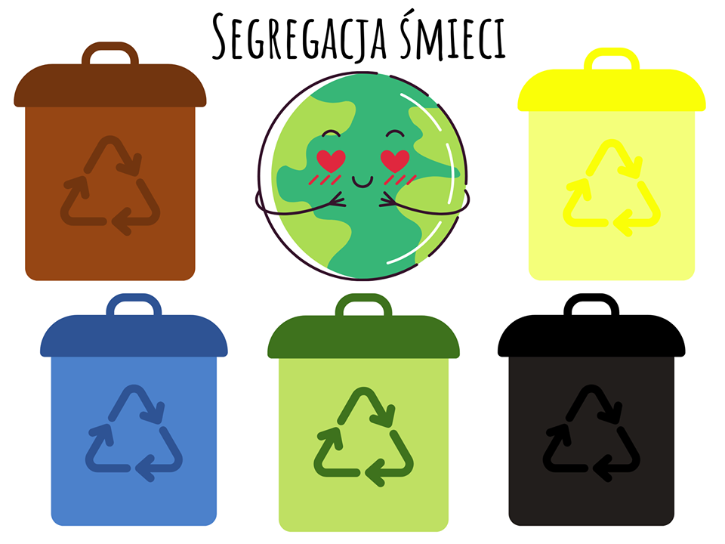

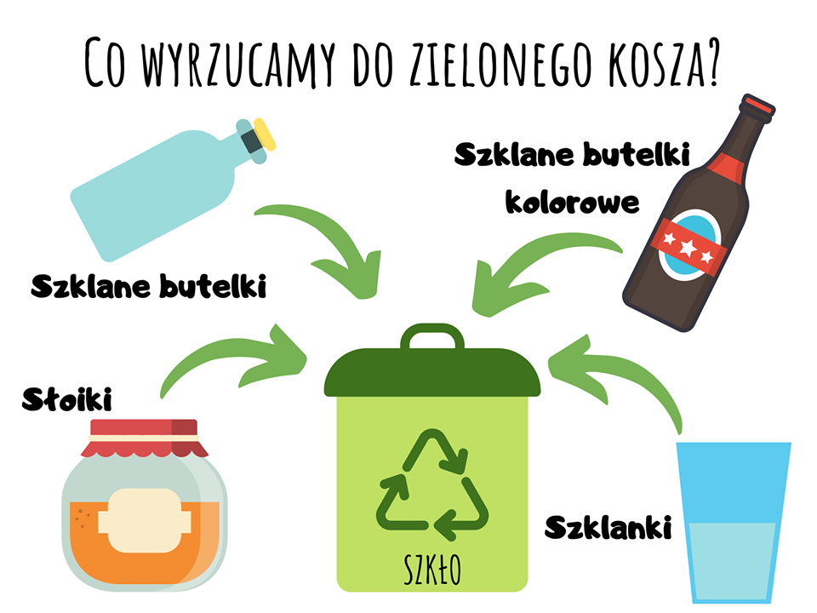

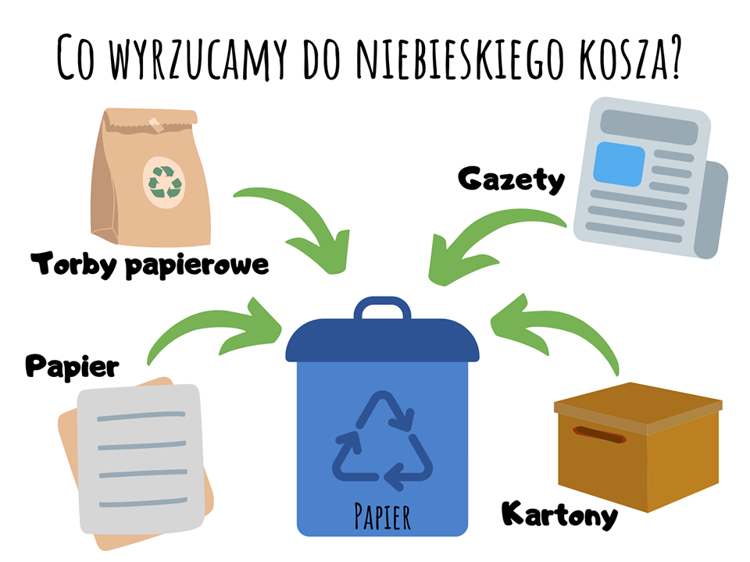

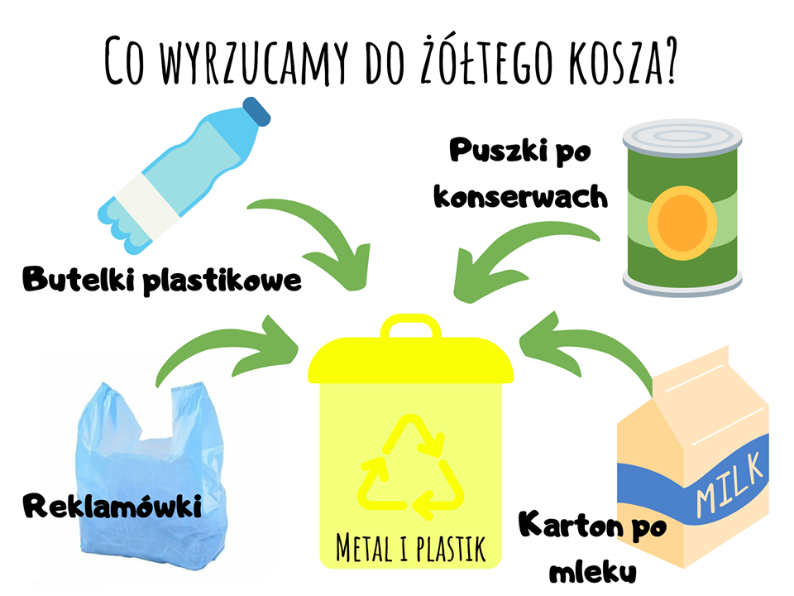

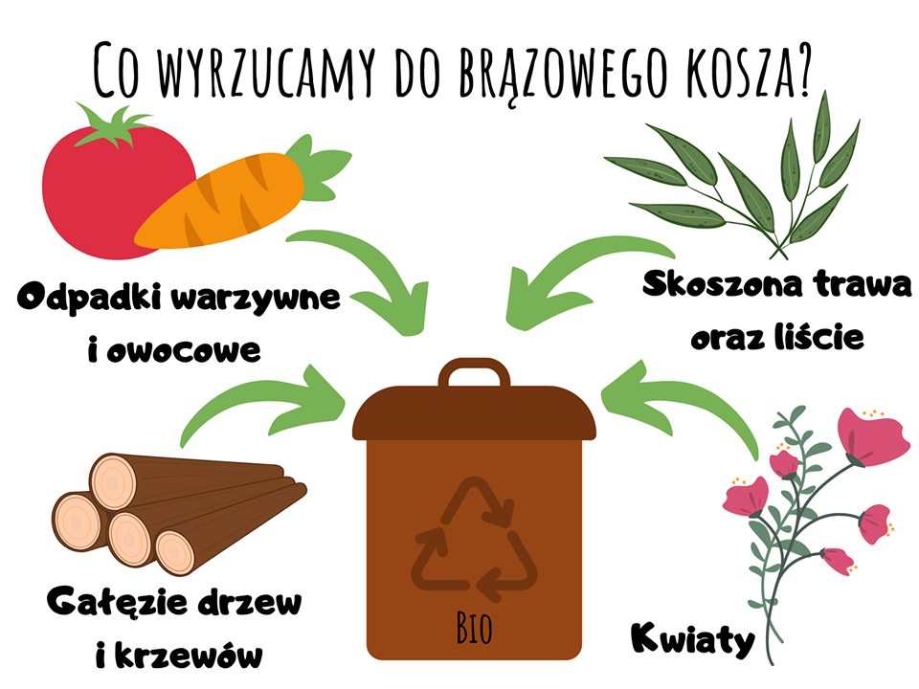

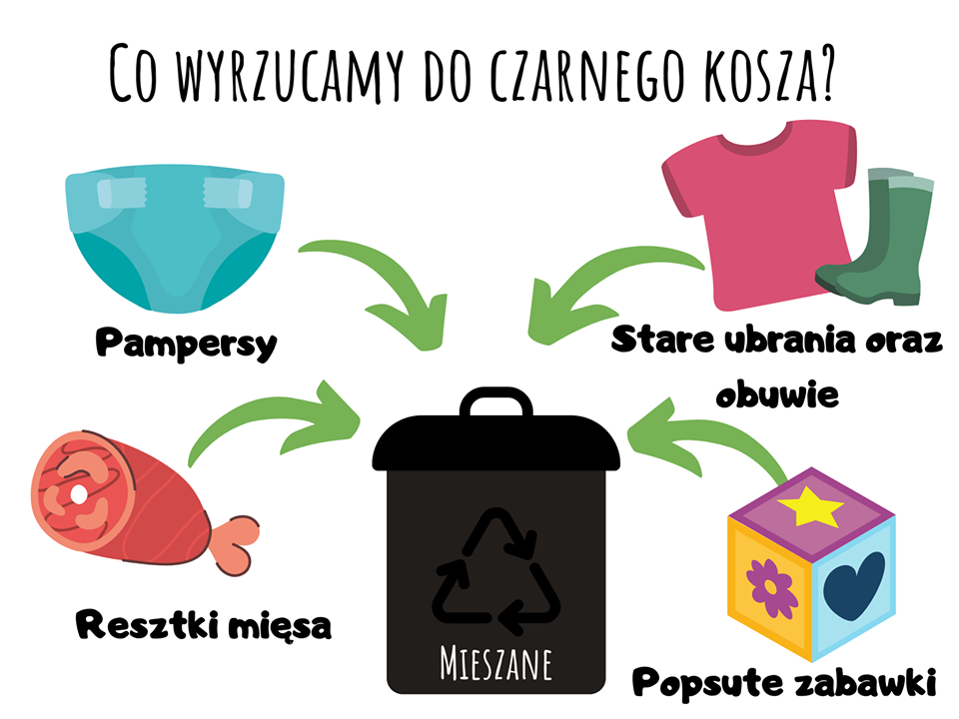

Żródło: <https://www.facebook.com/panianianatropiepomyslow/?eid=ARA6qpAH-y8mAZvkuMO9sHrkvhuz2bLrW2dz08bv4NOtqFSgUNrs9ym4HHJduo3_N2fX1yVTP6NVarvf>